
Input into the Draft NZ Disability Strategy 2026-2030
September 2025

Background
Our input into the draft NZDS is made on behalf of the Carers Alliance of 61 national not for profits and the peak body for carers, Carers NZ.

Many Alliance NGOs support disabled people and families; more than 40% of New Zealand’s 1m+ family carers have a disability and/or chronic health condition themselves. Carers NZ was formed by and for family carers in 1995 and acts as the ongoing Secretariat for the Carers Alliance, and for Young Carers NZ, a national information and advocacy network for children and young people in caring roles.

The Carers Alliance was established in 2004 with a specific initial purpose of calling for a Government Strategy to recognise and support our country’s family, whanau and aiga carers. The then Labour government implemented a Strategy and initial five-year Action Plan in 2008. Successive governments have developed and implemented two further five-year Action Plans. A fourth ‘rolling’ cross-government Action Plan will be decided by Cabinet soon. More than a dozen government agencies, led by MSD, are signatories to and have governance and working responsibilities for the Carers’ Strategy and its Action Plans. These agencies include Whaikaha.

The Carers Alliance is the Government’s partner to develop, monitor the delivery of, and support the strategic aims of the Carers’ Strategy and its Action Plans. This work includes consulting with disabled people and family carers to ensure Strategy actions reflect the priorities of our community.

The Carers’ Strategy, the Disability Strategy, maintaining voice/visibility

The Carers’ Strategy was developed after the implementation of the original Disability Strategy in 2001. Carers NZ and other Carers Alliance NGOs gave strong input into consultation for the 2001 Strategy and its resulting Objective 15: “value families, whanau, and people providing ongoing support”.

Objective 15 was one of the first formal government acknowledgements of New Zealanders in caring roles, building on the 1998 National Health Committee consultation and report, How Should We Care for the Carers.
While numerous government agencies have services and responsibilities for family carers – and many government action plans and strategies at least technically cover this large community of New Zealanders – the Disability Strategy has been foundational in its explicit recognition of carers since 2001.
This progress for carers must be sustained in the new Disability Strategy, feedback the Carers Alliance and NGO members have consistently provided to Whaikaha in advisory groups, strategic networks, and to its senior leaders in regular meetings since Whaikaha was established in 2022.
The current Draft NZ Disability Strategy is unfortunately weak in its language, not adequately recognising and valuing families, whanau and carers despite our considerable collective engagement efforts with Whaikaha. We recommend that this inclusion be strengthened in the new Disability Strategy, lest the early progress of Objective 15 almost a quarter century ago be lost.
Lack of appropriate inclusion and recognition of family carers in a refreshed NZ Disability Strategy also works against contemporary policy and service frameworks to support disabled people (where relevant), and Whaikaha’s leadership involvement in a new rolling Action Plan for the Carers’ Strategy. We ask that in the new Disability Strategy, Whaikaha ‘walk the walk’ to improve its inclusion and recognition for families, whanau and carers.
Giving feedback on the Draft NZ Disability Strategy
Carers NZ and Carers Alliance NGO members collectively promoted the opportunity for our communities to give input into the draft Strategy despite the tight consultation timeframe.
We encouraged participation in physical and online workshops and meetings, and also hosted a forum of Carers Alliance NGOs to provide input.
This submission reflects feedback from the September 2025 Carers Alliance meeting, which was hosted by Lisa Martin (Complex Care Group) and Zandra Vaccarino (NZ Down Syndrome Association and Carers Alliance executive).
More than a dozen Alliance NGOs attended the Draft NZ Disability Strategy consultation meeting, collectively representing many thousands of disabled people and families.
Below is our input for consideration by the Strategy refresh team.
We note that the Draft Strategy covers a five-year timeframe (2026 to 2030), a shift from previous 10 year strategies, so developments can keep pace with sector changes and New Zealand’s response to the UN Convention on the Rights of Persons with Disabilities.
Input Summary, Comments and suggestions
1. Strategy Framework and Overall Approach
- Lack of Family/Whānau/Carer Inclusion A recurring and significant general concern about the draft Strategy was insufficient and inconsistent inclusion of family, whānau and carers. Many Carers Alliance participants said the Draft Strategy heavily overlooked the critical role and needs of family carers, despite considerable involvement and input from our members into Whaikaha consultation processes over a long period. The Carers Alliance recommends that specific mention of family, whānau and carers be made in the Strategy vision and principles, and throughout priority areas, and/or that a dedicated section referring to them be added.
- Siloed Approach The Draft Strategy was criticised at the Carers Alliance consultation meeting for its siloed approach to different sectors (education, health, justice), with participants noting a lack of interconnectedness and holistic support for disabled people and their families.
- Measurable Outcomes Concerns were raised about the lack of measurable outcomes within the Draft Strategy, particularly in the health section; this lack will make it difficult to evaluate success. Some goals, like achieving the highest possible standard of health and wellbeing, felt unattainable without realistic goals and measurements.

2. Strategy Vision
The proposed Vision is that "New Zealand is an accessible and equitable society for disabled people and their whānau. A place where disabled people thrive, lead, and participate in all aspects of life.”
- Need for Support Context Suggestions include language like people being appropriately supported to thrive, lead, and participate, as current wording places the onus on disabled people to achieve this "miraculously, by themselves".
- Scope of Participation Feedback was that the Vision, like the full Draft Strategy, caters for disabled people for whom full participation in education and employment is an option, excluding those for whom these outcomes may be less possible. Disabled people are a large and diverse population, requiring broad coverage of key Strategy issues that is not apparent in the Draft Strategy.
- Explicit Inclusion of Family/Whānau NGO participants said there was a need to explicitly mention family/whānau and carers in the Vision, e.g. disabled people and their family/whānau, to ensure their inclusion and recognition throughout the new Strategy.

3. Strategy Principles
Proposed Strategy principles include Accessibility, Choice and Control, Equity Cultural Inclusion and Intersectionality, Human Rights, Participation and Inclusion, Respect and Dignity, and Te Tiriti o Waitangi.
- Equity, Cultural Inclusion, and Intersectionality Some saw "intersectionality" as a "jargon word" that needs a plain English alternative. Also, should "cultural inclusion" be separated or integrated with "participation and inclusion"? “Equity” should also perhaps be its own principle, focused on achieving equity between disabled and non-disabled people rather than being lumped together with cultural inclusion and intersectionality.
- Absence of EGL Principles There was strong disappointment that Enabling Good Lives principles were not part of the core Draft Strategy principles. The Draft Strategy also does not identify the three barriers of EGL: equity, choice, and community connection.
- Lack of Family/Whānau/Carer in Definitions Definitions of principles like choice and control lacked mention of whānau. There is general invisibility of family, whānau and carers throughout the principles – we propose that language be modified e.g. disabled people and their carers have the right to be active members of their communities.
- Supported Decision-Making Some noted that the principle of "Choice and Control" surprisingly lacks any mention of supported decision making to guide collaboration between disabled people and their families/carers.
- Societal Attitudes It was suggested that the principle"Respect and Dignity" should encompass societal change and attitudes towards disabled people and carers, noting a current lack of shared respect in the general community.
- Protections for Carers The Draft Strategy is silent about protections for carers or even crossover linkage to the Carers’ Strategy with its pending focus on protecting the wellbeing including financial wellbeing of family carers.
- No Feedback Loop It was noted that a structural issue in the Draft Strategy is that there is no clear feedback loop linking the five outcome areas to how these support the principles, leading to confusion.
- Principle Connection to Vision: If family, whānau and carers are to be included in the Strategy Vision, they must also "trickle down to the principles" to maintain coherence within the Strategy document.

4. Priority Outcome Areas and Actions
The five priority outcome areas are Education, Employment, Health, Housing, and Justice. Our feedback follows.
Education
Goal "Every learner is supported to attend, participate and progress in education. There is a high expectation that all learners – including disabled learners – will achieve their potential in the education setting of their choice.”

Feedback

Language Some disliked the phrase "disabled learners," preferring "people with learning challenges" or "people who may have a disability with learning challenges".
Age Range for Education Support Some questioned why Learning Support Coordinators are funded only for Year 1-8 students, arguing that neurodivergent disabled people often face more trouble in secondary school or higher education where they need the most support.
Lifelong Learning Some highlighted the absence of a strategy for lifelong education for disabled people, noting that education in the Draft Strategy is presented as stopping after school age. This is particularly relevant for adults who acquire disabilities (e.g. stroke survivors) and need support for learning and adaptation at all ages.
Family Education Several NGOs pointed out the need for "education of the family" so they can navigate flexible funding, respite, individualised funding and carer support forms etc. This investment would help to sustain disabled people and families in a complex and ever-changing disability system – building confidence and skills over time.
Measurement of Potential Some noted that the Draft Strategy doesn't specify how "achieve potential" in education will be measured, and there is no reference to vocational training choices.
Data Siloing Some expressed concern that education data is siloed and should be aggregated with data from MSD, Health, and Housing to better plan for disabled people.
Success Definition Some suggested that What success in Education means should include "accommodating needs" and "removing barriers”, as current Draft Strategy framing does not reference necessary support to achieve success.
Alternative Education Settings Some noted the omission of Health School/Takura Correspondence and homeschooling, which are crucial for many disabled young people unable to access mainstream education.
Mental Health Some highlighted the lack of mental health support in the Draft Strategy as a significant barrier to education for disabled young people.
Impact on Wider Whānau Some said the Draft Strategy doesn't address the impacts of disability on young carers (children of disabled people, and children and young people in caring roles for other disabled family members) who may have limited access to education or who are less likely to attend university or may face life-limiting barriers in their early working lives.
Communication Access Some noted the absence in the Draft Strategy of focus on learning and supporting languages like NZSL, Braille, and Augmentative and Alternative Communication (AAC) systems, which are fundamental for non-verbal, blind, or deaf students and their families.

Employment
Goal "Disabled people will have meaningful career opportunities equal to non-disabled people, and be valued in the same way. Disability-confident employers will recognise disabled people’s talents and will provide accessible and inclusive workplaces throughout the employment life cycle.”

Feedback

Exclusion of High Needs Individuals Some criticised the employment section of the Draft Strategy for "erasing every disabled person who will never be able to hold a mainstream job be able to work at all”. Some said the Draft Strategy primarily envisions “a cisgender white man in a wheelchair who works as an accountant”, not those with high needs who might engage in vocational services, social enterprises, or volunteering.
Carer Employment The Draft Strategy has no acknowledgement or mention of appropriate support for disabled people to enable family carers to participate in paid work, or to encourage flexible working arrangements for carers. The mostly unpaid work of family carers has a minimum annual economic contribution of $17.6 billion, yet many cannot participate in employment due to over-reliance on their care and support roles. The Draft Disability Strategy should have dovetailed better with the proposed new rolling Action Plan for the Carers’ Strategy, to strengthen solidarity of Whaikaha, DSS, and MSD in this area.
Disability Confident Employers Some questioned the widespread existence of Disability Confident Employers and argued that a separate strategy or larger societal initiative is needed to educate employers on how to be disability confident. There should also be visibility and support for existing training for employers, e.g. Autism NZ’s training for employers.
"Equal" vs. "Equity" Some challenged the term "equal" in the goal, stating that "equity" is more appropriate, as it acknowledges the need for accommodation and support to provide an equitable playing field.
Depersonalisation Some expressed concern that centralising information and guidance (Action 1) could risk "depersonalising" the approach and fail to account for individual needs.
Employer Perceptions Some worried about employers' economic concerns and myths and perceptions that may hinder their willingness to employ disabled people.
Ageing Workforce Some pointed out that the Draft Strategy could better address the needs of an ageing workforce and highlighted how improved accessibility and inclusion would benefit older people who may develop disabilities or need to remain in work due to financial necessity.

Health
Goal "Disabled people will achieve the highest possible standard of health and wellbeing. They will decide what this means for themselves and their whānau.”

Feedback

Mental Health There was general agreement that the Draft Strategy neglects mental health considerations in the mental health section.
Carer Wellbeing There was general agreement that the Draft Strategy neglects focus on "family wellbeing and mental health" and the profound impacts of caring on the physical and mental health of many family carers. It is suggested that phrases like "enhance quality of life for disabled people" should always include "and their family/whānau".
Transitions and Care Coordination Some called for planning for phases of transition (e.g. paediatric to adult care, specialist to GP care) and formalised care coordination or navigation services for disabled people with complex health issues to manage administrative load.
Inter-agency Coordination Some questioned whether the Draft Strategy addresses a coordinated health overlap between all these different entities (hospitals, GPs, health boards, respite providers, residential providers, schools etc). An NGO representative who is a parent of a high needs disabled young adult says "I can tell you it's not in there - it should be a priority, as current systems are utterly horrendous".
Unrealistic Goal Some found the goal of achieving the highest possible standard of health and wellbeing to be an unattainable and unrealistic goal given health equity reports here and globally show disabled people consistently have the worst health outcomes.

Housing
Goal "Disabled people and their whānau will have affordable, healthy, secure, and accessible homes that meet their needs.”

Feedback

Unattainable Vision/EGL Some said this goal also has an unobtainable vision statement, noting the unfortunate lack of reference to the Enabling Good Lives framework, which focuses on equity, choice, and community connection.
Voluntary Guidelines Some noted that “voluntary national guidelines on accessibility for residential dwellings" (Action 6) would be ineffective without mandatory requirements, given the current state of housing and increasing numbers of disabled and older people relying on rental accommodation.
Social and Support Needs Some said the Draft Strategy focuses on physical accommodation but fails to address the social and support side of housing for disabled people who would struggle to live independently without such support.
Exclusion of Renters/Non-Social Housing The Draft Strategy excludes disabled people who do not qualify for social housing and cannot afford to own a home, with no reference to rental housing or temporary accommodation.
High Needs Accommodation The Housing section of the Draft Strategy is silent on the needs of those with higher needs who rely on supported housing or residential care – the focus is on physical accessibility over other types of independent living or residential stock.
Data Collection Some criticised the proposed annual survey data (Action 5) as insufficient, arguing that it would not replace the detailed information previously provided by the Census regarding regional housing needs for disabled people, which gave guidance to regional councils.
Recommendation Consider adding an alignment with the Australian federal building code's "silver level of accessibility" and national rollout of "choice and community living" options for families.

Justice
Goal "Disabled people’s human rights and freedoms will be protected, and their disability rights will be realised. Disabled people will be treated fairly and equitably by the justice system. Justice system policies and practices will embed accessibility, inclusion, and lived experience.”

Feedback

Inherent Some argued that fairness and equity should be inherent to any justice system, and the meaning of "accessibility" needs clarification.
Violence Against Carers Some strongly highlighted the absence of any mention of "violence against the caregivers”, specifically "child-to-parent violence and abuse" (CAPFA), which is a significant issue for carers of disabled people. Elder abuse of older disabled people is also a growing social issue that could be flagged in the new Disability Strategy.
Supported Decision Making Some noted lack of reference to supported decision making in the justice section of the Draft Strategy. Accommodation for disabled people's specific understandings, communication challenges, and need for meaningful engagement within the justice process through supported decision making and assistance from communication experts is missing from the actions.
Undiagnosed Disabilities There was agreement that the Draft Strategy does not acknowledge or address the growing population of undiagnosed disabled people within the justice system (autism spectrum, intellectual disabilities, FASD, ADHD etc). The impacts of these undiagnosed conditions across justice and corrections are profound for disabled people, their families, and society and the Disability Strategy should aim to cover this in its justice content.
Underwhelming Actions Some found the justice section of the Draft Strategy “underwhelming”, suggesting that many proposed actions were already being addressed (e.g., Law Commission review, pilots) rather than including or exploring newer initiatives.

Thank you to the Disability Strategy refresh team for considering feedback from Carers NZ and the Carers Alliance. Our networks live with all of the issues covered by the Strategy – our feedback is based on our frontline and lived experience of disability.
Questions about our submission can be directed to info@carers.net.nz

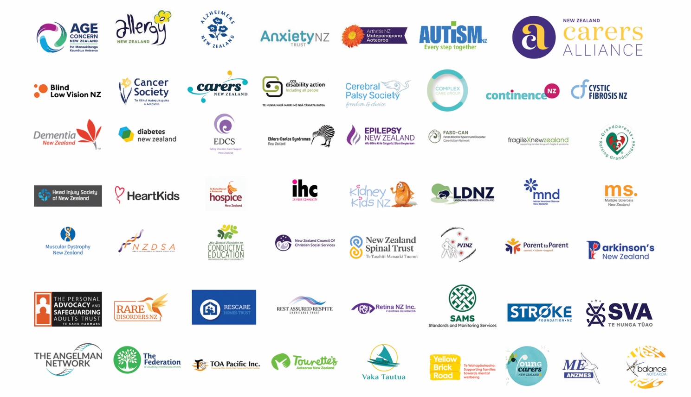

State of Caring report, 2022, Synergia.
New Zealand Disability Strategy, 2001, Objective 15
National Health Committee, 1998, How Should We Care for the Carers?
The Economic Contribution and Sacrifices of Unpaid Family Whānau and Aiga Carers in New Zealand, Infometrics, 2023

