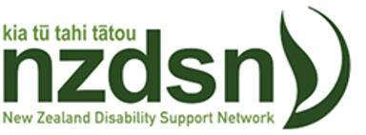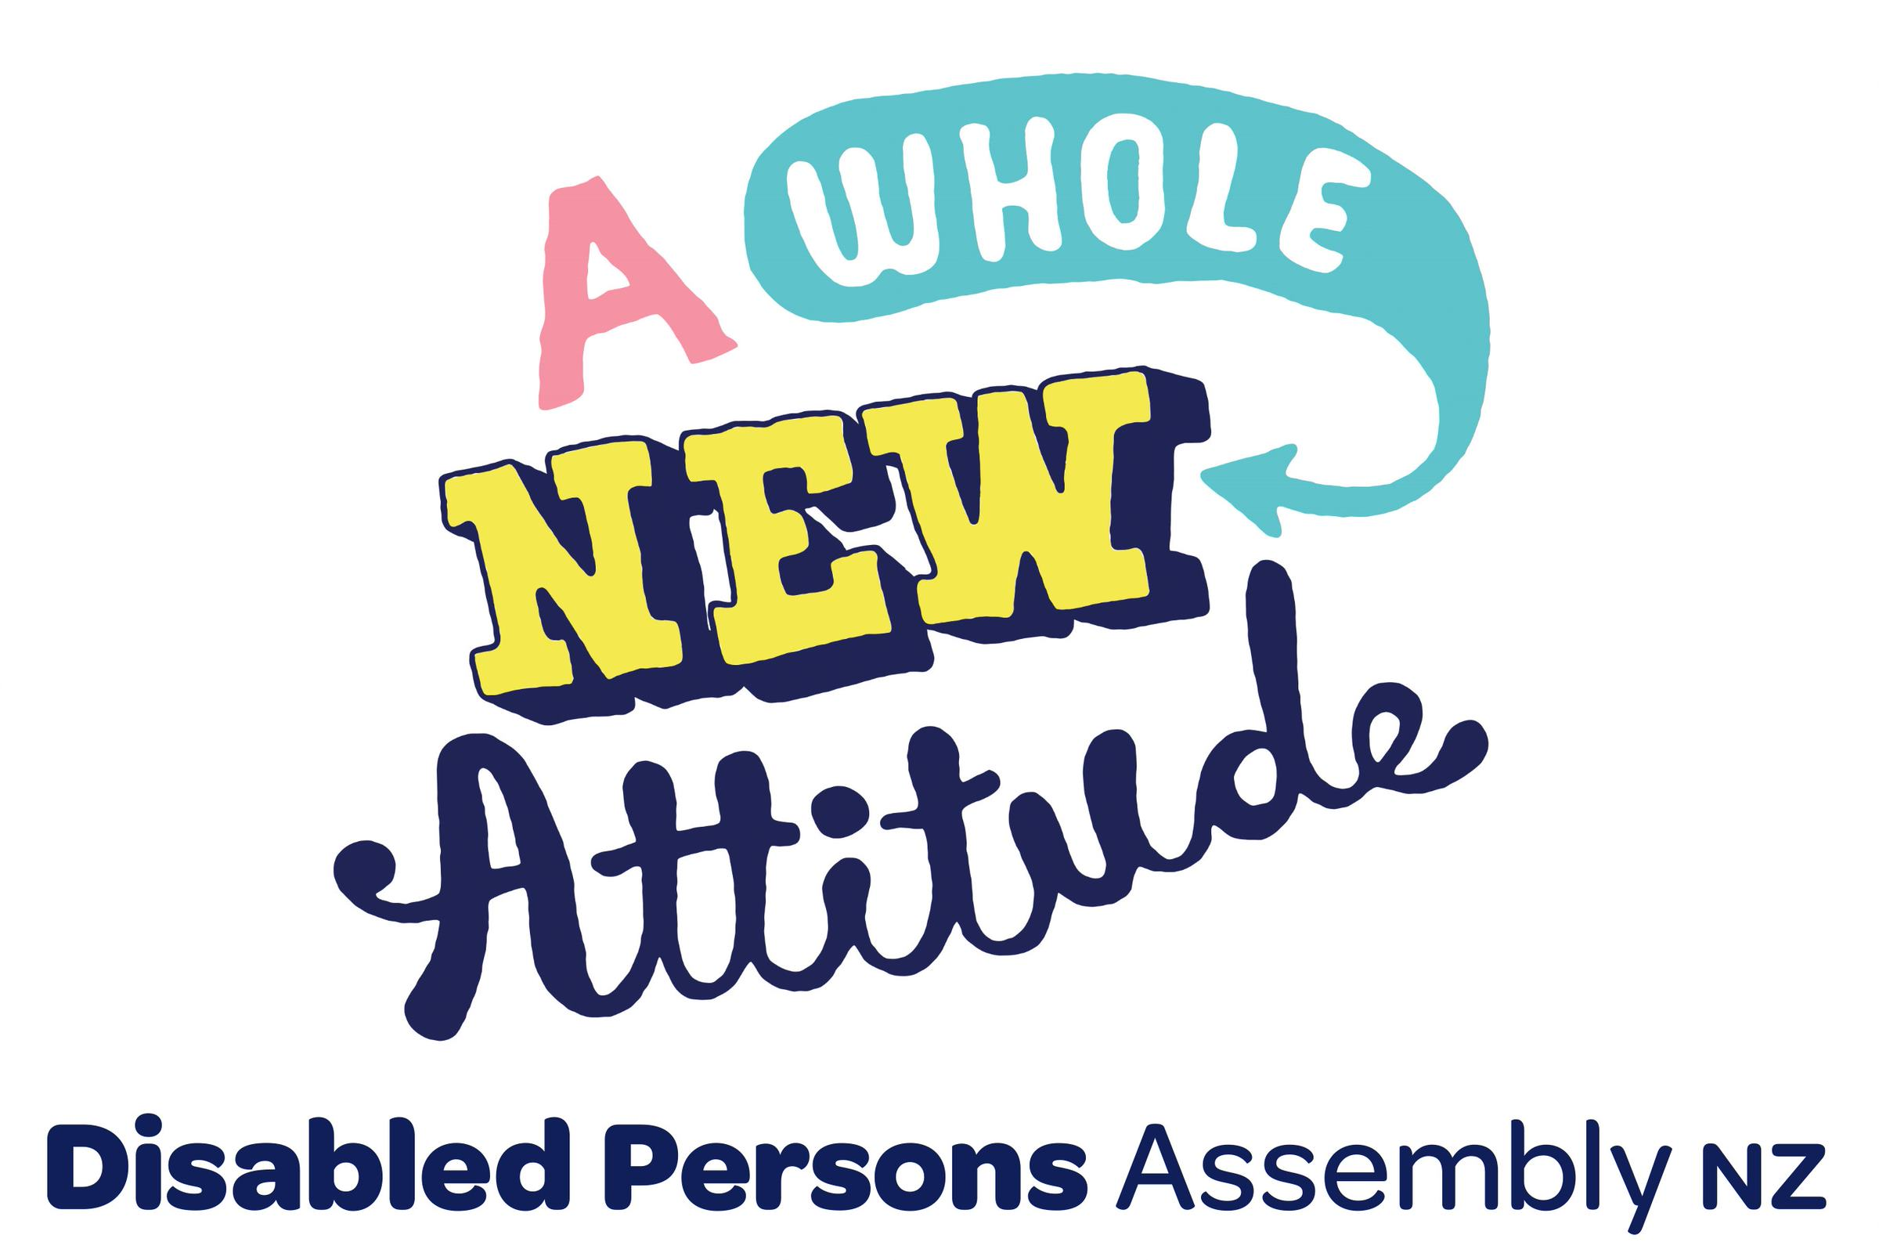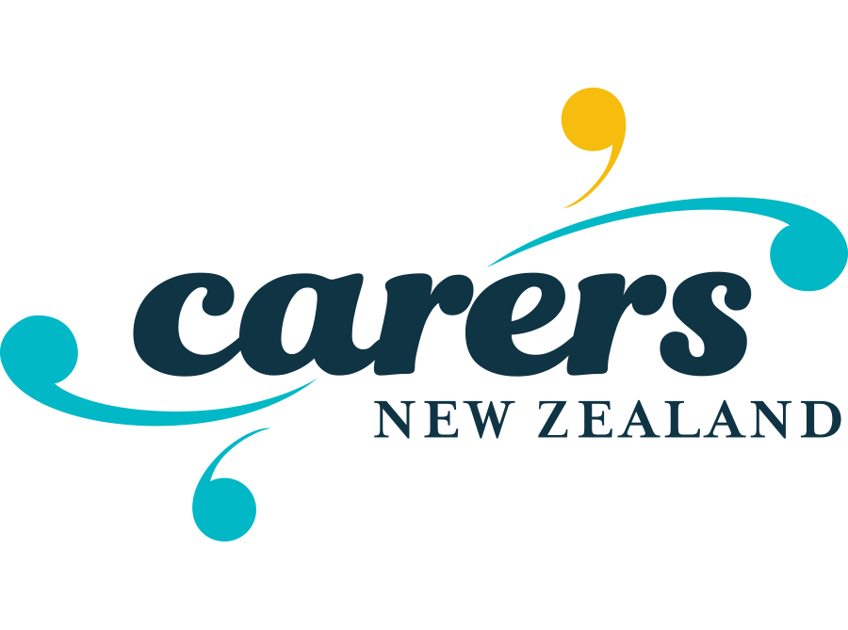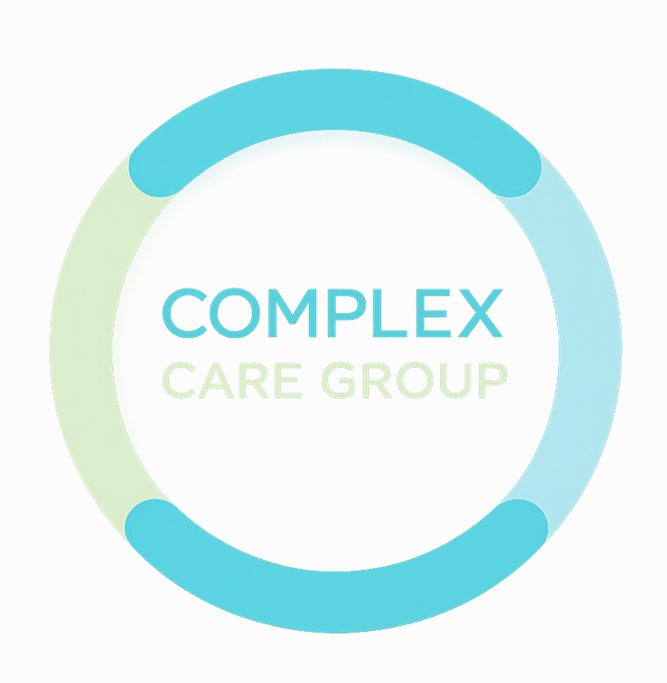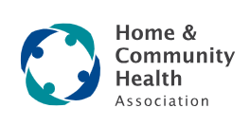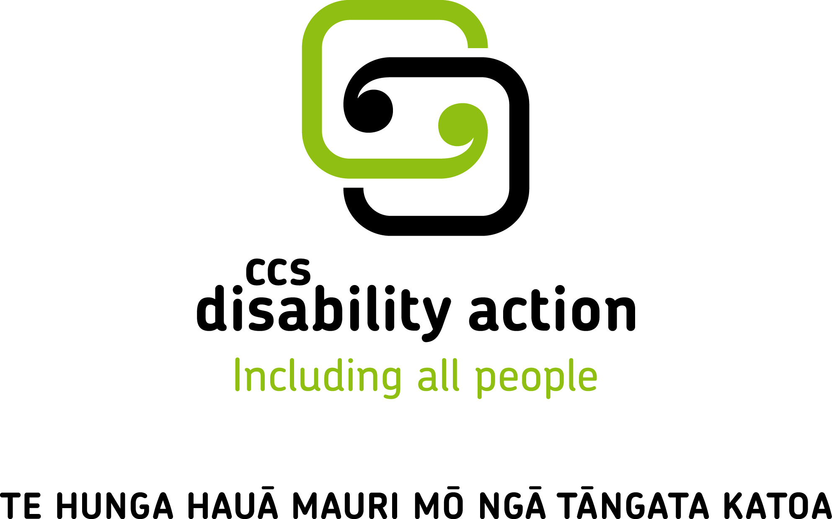

Joint Media Statement
For immediate release: 23 June 2027
Disabled People, Families, Carers and Providers Unite; Parliament Denying Disabled People and Their Families a Fair Say on Laws That Shape Their Lives
Eight national disability organisations - Disabled Persons Assembly (DPA), People First New Zealand, Carers NZ, Parents of Vision Impaired NZ, the Complex Care Group, CCS Disability Action, Home and Community Health Association (HCHA) and the New Zealand Disability Support Network (NZDSN) are calling on Parliament to halt the rushed progress of the Disability Support Services Bill and ensure meaningful engagement with the communities it affects.
Collectively, our organisations represent hundreds of thousands of disabled people, family carers, disabled people's organisations, advocacy groups, and support providers across Aotearoa.
Disabled people, families and the wider disability support sector are being denied a meaningful opportunity to have their say on decisions that directly affect them.
“While we support legislation that protects and strengthens the rights of disabled people and family carers, we are united in our concern that the process being used for this Bill fails to meaningfully involve disabled people, families, and the disability sector in its development,” says Debbie Hughes, Chief Executive of the NZDSN.
The group disputes Ministerial assurances that the Bill responds to consultation with disabled people and families.
“This Bill has been extremely reactive and has not been developed with the knowledge, involvement, or seriously needed expertise of disabled people and their representative organisations," says Kera Sherwood-O'Regan, National President of DPA.
"Only a handful of our organisations were briefed by the Minister about the Bill's existence – with our call finishing just 15 minutes before the public announcement. We directly raised serious concerns about the need for robust, accessible engagement and an extended consultation period. Instead, this process has been rushed, sloppy and inaccessible.
“We consider this a breach of the government's obligations under the United Nations Conventional on the Rights of Persons with Disabilities (UNCRPD).”
The parliamentary process has compounded these failures. The Select Committee has scheduled only three and a half days of hearings, all in Wellington, with just a few hours available each day for public participation – and no hearings anywhere else in the country.
“To make things worse, organisations representing thousands of New Zealanders have been allocated as little as five minutes to present, including time for questions from Committee members. Five minutes is simply not enough time to convey the concerns, experiences, expertise and aspirations of the communities we represent,” says Mel Smith, Chief Executive of CCS Disability Action.
The Disability Support Services Bill may not technically be proceeding under urgency, but from the perspective of disabled people and their families it has that effect.
“New Zealand has obligations under the UNCRPD to closely consult with and actively involve disabled people, through their representative organisations, in decisions that affect them,” explains Desrae Turvey, National Chairperson of People First New Zealand Ngā Tāngata Tuatahi.
“Meaningful participation cannot occur when people are given almost no time to understand proposals, engage with their communities, organise accessible responses, prepare submissions, and present their views.”
“For disabled people and their families, participation requires accessible formats, time to understand and discuss proposals, support to formulate responses, and opportunities to engage in ways that accommodate different communication needs."
Disabled people and their families deserve better.
“Parliament should not be making decisions about disabled people and families without disabled people and families having the opportunity to have input,” says Laurie Hilsgen, CEO of Carers NZ.
“A Bill that potentially has such major impacts for New Zealanders in caring situations should not be progressed without fair input from disabled people and family carers” says Lisa Martin, Director Complex Care Group.
“New Zealand deserves legislation that has been developed with the community it affects.”
ENDS

NOTES FOR EDITORS
About the Disability Support Services (DSS) Bill
The Disability Support Services Bill was introduced to Parliament by Minister for Disability Issues Hon. Louise Upston on 17 May 2026. It passed its first reading on 21 May 2026 and was immediately referred to the Social Services and Community Select Committee.
The Bill proposes to create the first foundational legislative framework for disability support services in Aotearoa New Zealand, covering eligibility, funding principles, the role of family and whānau, and the legal relationship between the Crown and family carers. It directly affects the approximately 55,000 disabled people currently receiving community and residential care, and around 26,000 disabled children accessing Child Development Services annually.
The timeline
Legislation in New Zealand typically takes around six months to pass, but the Disability Support Services (DSS) Bill is being processed on an accelerated timeline.
From introduction to submission close was just 25 days:
Bill introduced to Parliament | 17 May 2026
First reading passed | 21 May 2026
Referred to Social Services and Community Select Committee | 21 May 2026
Alternative formats on DSS Bill published | 2 June 2026
Submissions closed | 11–12 June 2026
Select Committee hearings | 23, 24, 25 and 30 June 2026
Select Committee report due back to Parliament | 12–13 August 2026
New Zealand's international obligations
New Zealand is a signatory to the United Nations Convention on the Rights of Persons with Disabilities (UNCRPD). Article 4.3 requires governments to closely consult with and actively involve disabled people, through their representative organisations, in developing legislation that affects them. The Government's own disclosure documents on this Bill acknowledge that this obligation has not been fully met.

Media contacts

NZDSN - Richard Irvine, 027 2327946
Disabled Persons Assembly (DPA) - Kera Sherwood-O'Regan, National President president@dpa.org.nz
People First New Zealand - Jordan Jacques, jordan@peoplefirst.org.nz
Carers NZ – Laurie Hilsgen CEO, 021 702922
Parents of Vision Impaired (NZ) Inc - Rebekah Graham, 022 6215740
CCS Disability Action – Lucy Green, 027 4349256
HCHA – Lisa Foster, CEO, 021 989 617
Complex Care Group - Lisa Martin, Director, 027 2667690

